
Sreenidhi Institute of Science and Technology
Regulations:
A12
(An Autonomous Institution)
Code No: 3B514 Date:26-Nov-16(FN)
B. TECH. III-Year I-Semester Examinations, Nov/Dec 2016 (Supplementary)
DESIGN OF MACHINE MEMBERS – I (ME)

Time: 3 Hours Max. Marks: 70

Note: A) No additional answer sheets will be provided.
B) Assume any missing data.

Part - A
Max.Marks:20

Answer all QUESTIONS. EACH QUESTION CARRIES 2 MARKS.

- Two shafts A and B are made of the same material. The diameter of shaft A is twice as that of shaft B. The power transmitted by the shaft A will be __________ of shaft B.
- List the reasons for stress concentration.
- Draw the load - time curves for fluctuating, repeated and reversed loading conditions.
- Differentiate muff and split muff coupling.
- Differentiate saddle key and sunk key.
- What is helical torsion spring? How does it differ from helical compression spring
- What is Wahl factor? Where is it used?
- Draw double riveted double strap (equal) butt joint.
- Discuss on bolts of uniform strength.
- Write down the expression for strength of transverse fillet weld in terms of permissible tensile stress, leg of weld and length of welded joint.

Part – B
Max.Marks:50
ANSWER ANY FIVE QUESTIONS. EACH QUESTION CARRIES 10 MARKS.
Note:- All sub-sections of a question must be answered at one place only

1. a) Define factor of safety and what are the factors to be considered for deciding the magnitude of factor of safety? 4M
b) A mild steel shaft of 50 mm diameter is subjected to a bending moment of 2000 N-m and a torque T. if the yield point of the steel in tension is 200 MPa, find the maximum value of this torque without causing yielding of the shaft 6M

2 a) A solid circular shaft, 15 mm in diameter, is subjected to torsional shear stress, that varies from 0 to 35 N/mm² and at the same time, is subjected to an axial stress that varies from -15 to +30 N/mm². The frequency of variation of these stresses is equal to the shaft speed. The shaft is made of steel whose ultimate strength is 540 N/mm² and yield strength is 400 N/mm² and the corrected endurance limit of the shaft is 200 N/mm². Determine the factor of safety? 6M
b) How the shafts are designed against fluctuating and shock loads 4M

3 It is required to design a cotter joint to connect two steel rods of equal diameter. Each rod is subjected to an axial tensile force of 50 KN. Take plain carbon steel whose yield strength is 400 N/mm² . Consider factor safety as 6 for rods, spigot end and socked end and 4 for cotter. 10M
4 A bracket is supported by means of 4 rivets of same size, as shown in fig., determine the diameter of the rivet if the maximum shear stress is 140 MPa. 10M
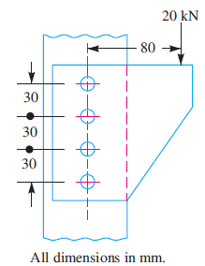
5 a) What are the various types of springs used in practice and mention their advantages and applications.
b) Design a close coiled helical compression spring for a service load of 3KN. the axial deflection of the spring for the load range is 6 mm. assume a spring index of 5. The permissible shear stress intensity is 420 MPa and modulus of rigidity is 84KN/mm²
10M
6 A bracket as shown in fig., carries a load of 40 KN. Calculate size of the weld, if the allowable shear stress is not to exceed 80MPa. 10M
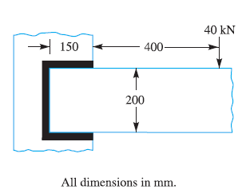
7 Design a muff coupling, which is used to connect two steel shafts transmitting 25 KW power at 360 rpm. The shafts and key are made of plain carbon steel 30C8 whose yield strength in tension and compression is 400 N/mm². The sleeve is made of grey cast iron FG 200 whose ultimate strength is 200 N/mm². The factor safety for the shafts and key is 4. For sleeve, the factor of safety is 6. 10M

8 a) List the locking devices for nut and show them with neat sketches 5M
b) List the types of welded joints and show them with neat sketches 5M
-- 00 -- 00 --

